Open-jdk Download and Installation.

**Download**

1. First go to this link. <https://www.oracle.com/technetwork/java/javase/downloads/index.html>

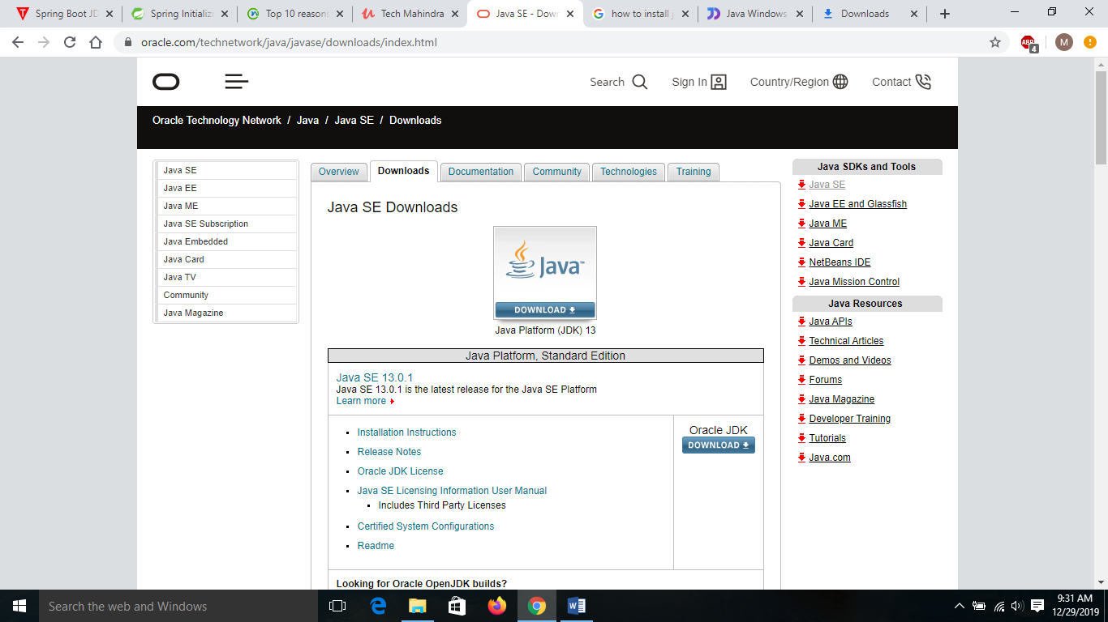

2. Click on Oracle open JDK link. The following window will be displayed.

3. Now click on JDK 13.

4. Now click on java SE 13.

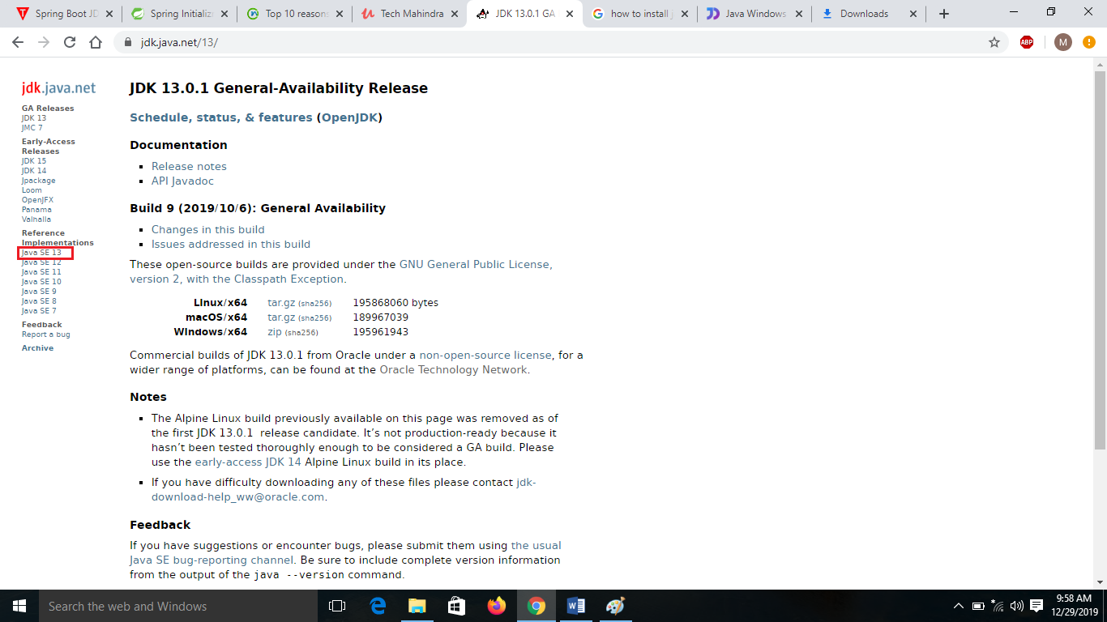

5. Now choose the operating system which you have.

6. Finally a zip file will be download.

==

**Installation:**

Create a folder “java” in your desired location,for example E:\u01\java.

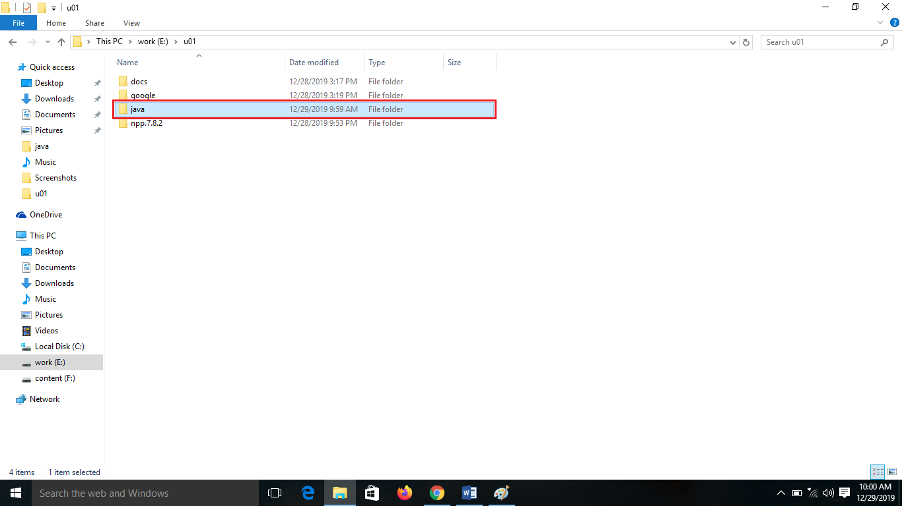

Copy the openjdk-13+33_windows-x64_bin zip file from downloads folder and paste it into E:\u01\java folder.

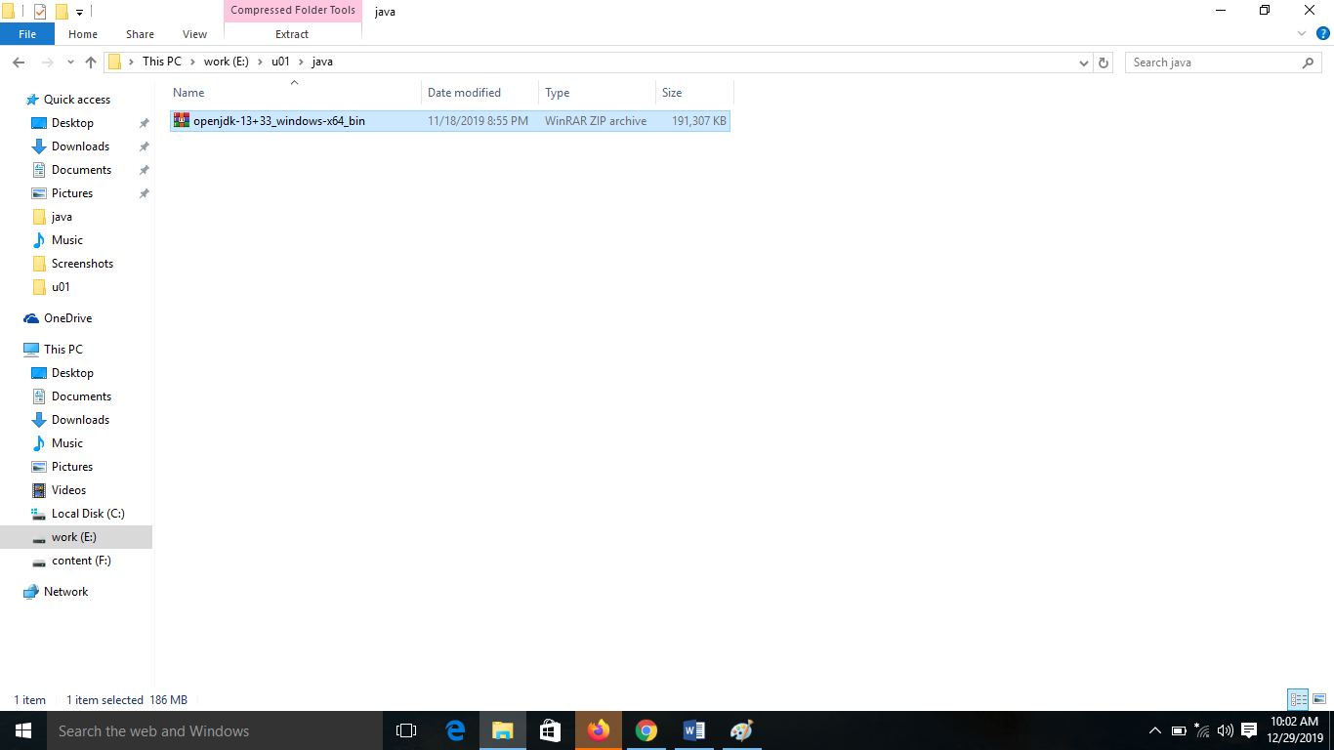

Right click on the openjdk zip file and select **Extract Here** option, then it will create a **jdk-13** folder.

Delete the copied zip file from that location E:\u01\java.

==

**Check the java version**

Open the cmd prompt from E:\u01\java\jdk-13\bin location

Type java –version in the command prompt and press enter, then it will the java version information.

If it will show version info means your installation successful.

==

Java first program, Compilation, Execution.

**How to write a java first program?**

Use any text editor such as notepad++ and write your first program like below and save as Test.java

|  |
| --- |
| class Test{  public static void main(String[] args){  System.out.println("Hello World");  }  } |

**How to compile java file?**

Move the .java file to bin folder, then open command prompt from that bin folder. Type**javac** command and pass .java file as an input and press the enter button. For Example: .\bin> javac Test.java

**How to run java class file?**

After compilation successful, compiler will generates a .class file in current working directory.Open command prompt from bin folder, type **java** command and pass .class file as an input and press the enter button. For Example: .\bin> java Test